Research For Image Processing Group Assignment

Contents

Challenges in Face Detection 1

Applications of Face Detection Systems 1

Different Techniques for Face Detection 2

Features based approaches 2

Active shape model 2

Low Level Analysis 3

Feature Analysis 4

Image based approaches 5

# Challenges in Face Detection

* **Too many faces** in an image
* **Odd expressions** not recognisable
* **Illumination**, different lighting within the image
* **Bad** **resolution**
* Face occultation (glasses, scarf, hat, hand, hair, etc)
* **Skin Colour**
* **Distance** between face and camera
* **Orientation**, when the face is positioned at an angle that reduces accuracy

# Applications of Face Detection Systems

* Gender Identification
* Document control and access control
* Human Computer Interaction
* Biometric attendance
* Photography
* Face recognition
* Marketing Face detection

# Different Techniques for Face Detection

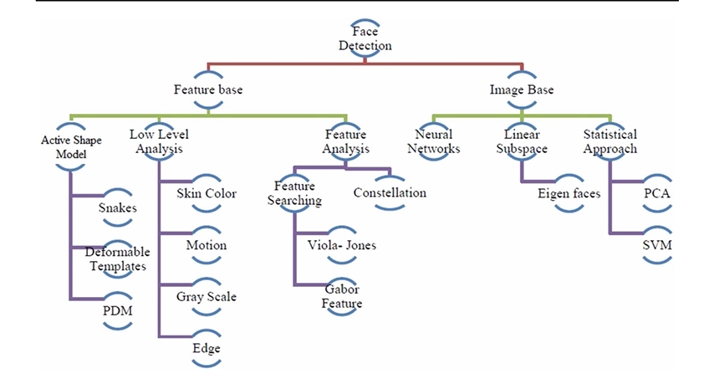

Face detection is when a computer determines the location of a face and its relevant size in an image. The facial features are detected, and background objects are ignored. Face detection can be seen as a case of face localization.

Face localization is the task of identifying the locations and sizes of a known number of faces. There are two types of detecting faces in an image.

## Features based approaches

**Feature** based approach: This approach tries extracting features from the image and match it against its knowledge of facial features.

### Active shape model

**ASM** automatically locates landmark points that define the shape of any statistically modelled object in an image. (E.g. Eyes, lips, nose, mouth and eyebrows)

There is a training stage for ASMs which is the building of a statistical facial model containing images with manually annotated landmarks. ASM can be broken down into 3 parts:

1. Snakes
2. Point Distribution Model (PDM)
3. Deformable Templates

#### Snakes

**Snakes** are used to identify head boundaries. To achieve this a snake is first initialized at the proximity around a head boundary. Then looks at the edges within that boundary and assumes the shape of the head from that. The evolution of the snake is by minimizing an energy function,

Esnake = Einternal +Eexternal

Einternal and Eexternal are internal and external energy functions.

**Energy minimization** is done by optimizing the steepest gradient descent function.   
**Internal energy** focuses on the intrinsic properties of the snake. Naturally shrinking or expanding.  
**External energy** counteracts the internal energy and enables the contours to deviate from the natural shape and assume the shape of nearby features within the head boundary at a state of equilibria.

Snakes are not good for extracting nonconvex features

#### Point Distribution Model (PDM)

**PDM** focuses on representing shapes as vectors and applying standard statistical methods to them. These models learn allowable constellations of shape points from training examples and use principal components to build the PDM.

#### Deformable Templates

**Deformable templates** consider a priori of facial features to improve the performance of snakes.

Based on narrow valley, edge, peak, and brightness. Other than face boundary, salient feature extraction is a great challenge of face recognition.

**Salient features** are eyes, nose, mouth and eyebrows

E = Ev + Ee + Ep + Ei + Einternal

Ev = External energy valley  
Ee = External energy edges  
Ep = External energy peak  
Ei = External energy image brightness  
Einternal = Internal energy

### Low Level Analysis

#### Skin colour base:

The colour of a person’s skin is a very important feature of their face. It has many benefits such as:

* Faster processing than other facial features
* Is orientation invariant with certain lighting conditions
* Motion estimation easier cause translation model is only needed

It also has several problems as well:

* Ambient lighting can affect the image
* Object movement

**Simplest skin-colour algorithms** to be used for detecting skin pixels. Pixels for skin regions can be detected using a normalized colour histogram and can be normalized for changes in intensity on dividing by luminance.

##### RGB – rg Normalized Colour Conversion

Conversion of an [R, G, B] vector into an [r, g] vector of normalized colour.  
Normalization involves converting the RGB values into a relative proportion of red and green components, effectively making the colour more robust to lighting variations.  
By converting it, it simplifies the process of identifying skin tone regions.  
The problem with this method is it may fail when there are large skin regions in the image including arms or legs.

YCbCr Colour Space and Skin Detection:

**YCbCr Colour Space** separates an image into **luminance (Y)** and **chrominance (Cb and Cr)** components. Skin tones tend to cluster within specific ranges of **Cb (blue difference chroma)** and **Cr (red difference chroma)** values.  
Using an algorithm to set Cr and Cb thresholds as [Cr1, Cr2] and [Cb1, Cb2] so if a pixel falls within those thresholds it’ll be classified as skin.  
Problem with this is it may fail using images that contain other skin regions besides the face.

##### HSV Colour Space:

Using HSV you can represent the colours with H, and the change the saturation with S where skin regions tend to be predictable, using similar thresholds as [H1, S1] and [H2, S2].

#### Implementation Steps for Skin Detection

1. Classify the skin region using one of the following:
   1. RGB
   2. YCbCr
   3. HSV
2. Apply a threshold to mask out all non-skin regions
3. Draw a bounding box around the detected skin regions to extract the face from the image

### Feature Analysis

The purpose of feature analysis is to find structural features that exist even when the pose, viewpoint or lighting varies and then using those features to locate faces. Design for face localization.

#### Feature Searching:

Viola and Jones came up with an approach for object detection which minimized computation time while being very accurate at detection. The approach relies on the use of Haar-like features that are evaluated quickly through the use of a new image representation. Works of the integral image generating a large set of features and using boosting algorithms from AdaBoost to reduce the over complete set. The detector is applied in a scanning fashion on grey scaled images. There are three key supports:

* **Integral image** which allows the features used by our detector to be computed quickly.
* **Classifier** built using the AdaBoost learning algorithm to select a small number of critical visual feature from a large set of potential features.
* **Combining classifiers** in a cascade which allows background regions of the image to be quickly discarded while focusing on the face-like regions more.

Advantages:

* Admired for face detection in real time
* Uncompetitive detection speed
* Highly accurate
* Low false positive rate

Limitations:

* Long training time
* Limited head poses
* Do not detect black faces (Racist)

#### Local Binary Pattern

Technique is very effective to describe the image texture features. Used for **image retrieval**, **texture examination, face recognition, image segmentation**, etc. Is recently used to detect moving objects via background subtraction. In LBP **every pixel** **has a texture value**, which can be combined with target for tracking thermos graphic and monochromatic video.

Advantages:

* Describe Image texture
* Texture analysis, image retrieval, face recognition and image segmentation
* Detection of moving objects via background subtraction
* Tolerance against monotonic illumination changes

Limitations:

* Sensitive to small changes in face localization
* Using large local regions increases errors
* Insufficient for non-monotonic illumination changes
* Only used for binary and gray images

#### AdaBoost Algorithm for face detection

## Image based approaches

**Image** based approach: This approach tries to get the best match between training and testing images. ( more ML than image processing )